
Real-Time Open-Source Transaction Monitoring

Business Intelligence, Analytics and Reporting
Product Guidance Document
Author: Sandy Labuschagne - Tazama
July 2025
Table of Contents
1 Introduction 3
1.1 Tazama System Overview 3
1.2 BIAR Ecosystem Overview 4
1.3 Document Purpose 6
2 Context 7
2.1 Stakeholders 7
2.2 Business Processes 8
2.3 Data Product Classes 10
2.4 Information Delivery Tools 10
3 BIAR Conceptual Design 13
4 Principles and Guidance 14
Appendix A: Layered Architectural Pattern 18

Introduction

Tazama System Overview
The Tazama Transaction Monitoring System (TMS) is a rules-based forward-chaining inference engine that ingests transaction data as JSON-formatted ISO20022 messages and evaluates the data in real-time. Tazama uses a number of pre-built and configured rule processors to look for fraud and money-laundering behaviors. Rule results are summarized into fraud and money-laundering scenarios (known as typologies) and the system is able to block or flag transactions if typologies breach configured thresholds.
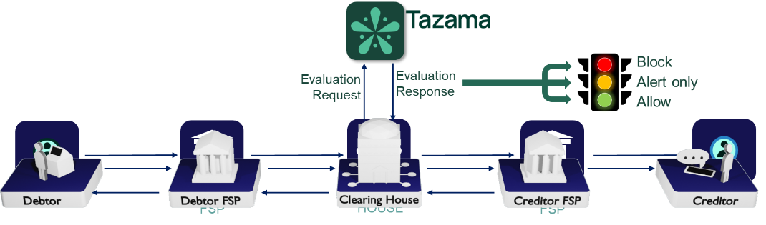
The core detection capability within the platform is distributed across 3 distinct steps in the end-to-end evaluation flow.
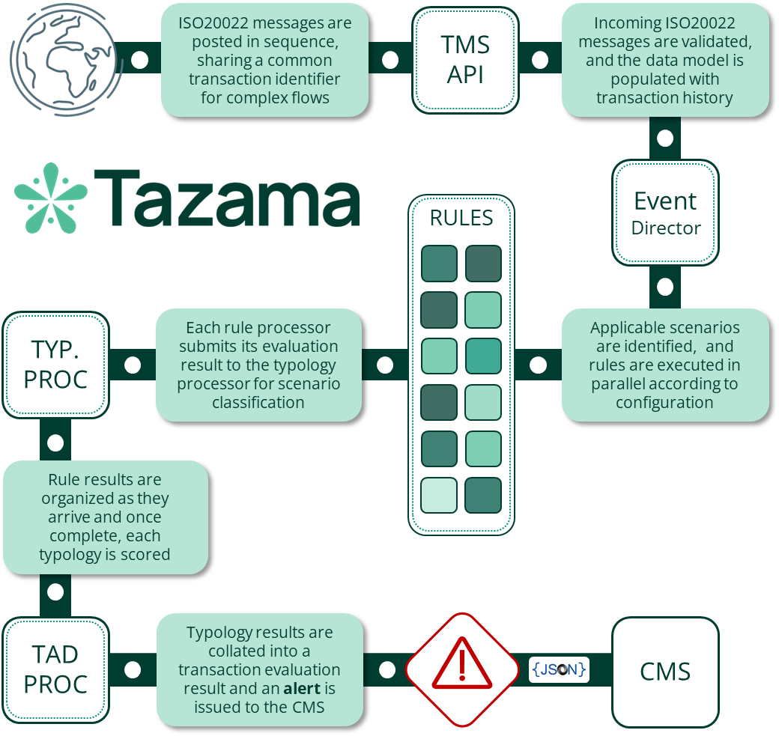
Once data is ingested into the transaction history by the TMS API, the Event Director (ED) performs an initial "triage" step to determine if the transaction should be inspected by the platform, and in what way. Currently this is a very simple decision based on the transaction type only (i.e. pain.001, pain.013, pacs.008 and pacs.002), though we envisage that the decision-making here can be more complex in the future by inspecting attributes contained in the message. For now, the ED uses the transaction type to select the typologies that are to be evaluated and triggers the rules required by the typologies. The ED routing is configured via a network map that defines the hierarchy of typologies and rules.
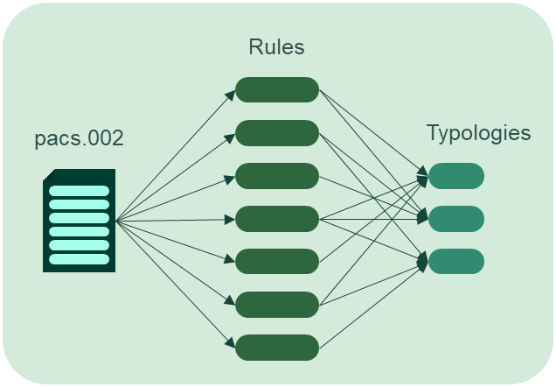
Each rule processor that receives the trigger payload from the Event Director evaluates the transaction and the historical behavior of the transaction participants according to the rule’s specification and configuration. Rule processors are driven by a combination of parameters and result category specifications to determine only one of a configurable set of related outcomes. The rule outcome is then submitted to the typology processor for scoring.
The typology processor assigns a weighting to each rule outcome as it is received based on the rule’s parent typologies’ configurations. Once all the rule results for a specific typology have been received, the typology adds all the weighted scores together to form the typology score. The typology score can be evaluated against an "interdiction" threshold to determine if the client system should be instructed to block a transaction "in flight". The typology configuration also contains an investigation threshold that will trigger a review or investigation process at the end of the transaction evaluation.
Once these three steps are complete, the evaluation of the transaction is wrapped up in the Transaction Aggregation and Decisioning Processor where the results from typologies are combined and reviewed to determine if an investigation alert should be sent to the Case Management System. If any typology had breached either its investigation or interdiction threshold, the system would trigger an investigation alert for that transaction.
The Tazama system is currently provided as a software engine and as such is generally implemented as a back-end service that taps into transaction flows.

BIAR Ecosystem Overview
The Tazama TMS is intended as a core component of a wider ecosystem that comprises of several components designed to combine into a comprehensive fraud and money-laundering management ecosystem. A number of these new components are currently under development. This wider ecosystem shown in the diagram below includes the Business Intelligence, Analytics and Reporting (BIAR) module and the Data Lakehouse which make up the BIAR ecosystem.
The purpose of the BIAR ecosystem is to unlock the full value of data collected through core fraud detection, transaction monitoring operations and case and investigation management, by enabling timely insights, evidence generation, decision support, and regulatory compliance.
Data Lakehouse
Tazama will implement a Data Lakehouse architecture rather than a traditional data warehouse or data lake. This design combines the scalability and flexibility of data lakes with the transactional reliability and performance of data warehouses—providing a unified foundation that supports real-time analytics, machine learning, and BI use cases.
The Data Lakehouse will ingest data from the following sources:
- Transaction Monitoring System (TMS) ODS
- Case and Investigation Management System (CIMS) ODS
- Metadata from CIMS Unstructured Documents
- External Data Sources
The Data Lakehouse will serve as a central analytical repository, providing curated data to:
- The Investigation Module for advanced analytics and visualizations
- The BIAR module for dashboards, reports, and predictive models
- The Simulation Sandbox for rule evaluation and historical replay

BIAR module
The BIAR module will be built around JupyterLab, a leading open-source environment for data science, artificial intelligence, and machine learning. It enables flexible, notebook-driven exploration, advanced analytics, and model development by technical users.
To support broader, non-technical audiences, a self-service Business Intelligence (BI) tool—Apache Superset—will be deployed alongside JupyterLab. Superset enables drag-and-drop dashboarding, ad hoc exploration, and report sharing through a secure, role-based interface.
The BIAR ecosystem will support:
- Operational monitoring – dashboards and KPIs for real-time oversight
- Regulatory reporting – scheduled and auditable reports for compliance
- Data exploration and feature engineering – via notebooks and datasets
- Model development and scoring – using integrated Machine Learning (ML) tooling
- Collaboration and knowledge sharing – through reusable, curated data products
Together, the Data Lakehouse and BIAR module will deliver a scalable, extensible ecosystem aligned with Tazama’s mission to make fraud detection accessible and cost-effective in order to promote financial inclusion and trust by providing a scalable, flexible, and intelligent fraud and money-laundering monitoring framework.

Document Purpose
The purpose of this document is to provide an overview of the principles and guidelines for the BIAR ecosystem to aid in the design and development of these components in the broader Tazama ecosystem.

Context

Stakeholders
The following table describes the stakeholders in the BIAR ecosystem, their primary responsibilities, and the data products that are expected to interact with.
# | Role | Data products | Primary Responsibilities | Examples
1 | Investigator/ Fraud Analyst | Dashboards  Visualizations  Reports | Use dashboards and reports for analysis and evidence gathering  Submit data queries or feedback  Interact with alerts/ cases/ investigations  Structured or goal-driven data exploration | Network visualization of linked accounts  Prior transactions for customer or account  Transaction Patterns  Geographic transaction footprint  Fraud trend analysis dashboard
2 | Data Analyst/ Data Engineer | Dashboards  Visualizations  Notebooks  Data sets  Data pipelines | Ingest, transform, and manage data pipelines  Develop curated gold tables  Manage data models | Jupyter exploration notebook  Data products (e.g. dashboards, reports, data sets and visualizations)  Curated transaction dataset  Batch data feed  Enriched customer data view  Real-time analytics
3 | Data Scientist/ ML Engineer | Analytics  Notebooks  Model Outputs  Data Sets  Features | Conduct exploratory data analysis  Develop and deploy ML models and analyses  Monitor models and performance | Model training notebook  Dataset for anomaly detection  Classification model output table  Rule effectiveness dashboard  False positive analysis dashboard
4 | Supervisor | Dashboards  Reports | Review reports  Monitor team performance  Review investigation workflows and case handling quality | Case & investigations summary dashboard  Case Tracking dashboard  Suspicious Activity Report (SAR)  Investigation Turnaround Time Report  Investigator case workload dashboard
5 | Compliance Officer | Reports  Dashboards  Visualizations | Ensure RBAC, data masking, and audit trails in place  Ensure compliance with regulatory obligations  Review flagged transactions and file reports | Suspicious Transaction Report (STR)  Suspicious Activity Report (SAR)  Compliance dashboard  Reportable jurisdiction heatmap
6 | Executive / Manager | Reports, Dashboards | Monitor overall performance and risk trends at a high level  Make strategic decisions | Executive overview dashboard  Management dashboard
7 | Auditor | Reports  Model Outputs | Review data integrity, system behavior, and audit logs for internal and external audits | System access log report  Model version audit view  Case audit summary  Data change history
8 | Regulator | Reports | Request and review reports  Validate compliance with regulations  Review reports of suspicious behaviour | Quarterly compliance report  SAR  STR
# | Role | Data products | Primary Responsibilities | Examples
9 | Administrator | Reports | Manage platform access, permissions, and data sources  Ensure system health and security  Configure and manage tools like Superset, JupyterHub, and Voila  Deploy data products | System Logs/ User Access Reports  Metadata Reports  Error and failure tracking dashboard  Data Source Health Dashboard  System performance dashboard  API response time dashboard
10 | BI Developer / Dashboard Engineer | Reports  Dashboards  Visualizations  Notebooks | Design and implement dashboards/ data products  Convert notebooks into Voila/Solara apps  Integrate Superset views | Data products (e.g. dashboards, reports, data sets and visualizations)

Business Processes
The following business process covers the end-to-end process of getting data into and out of the BIAR ecosystem.
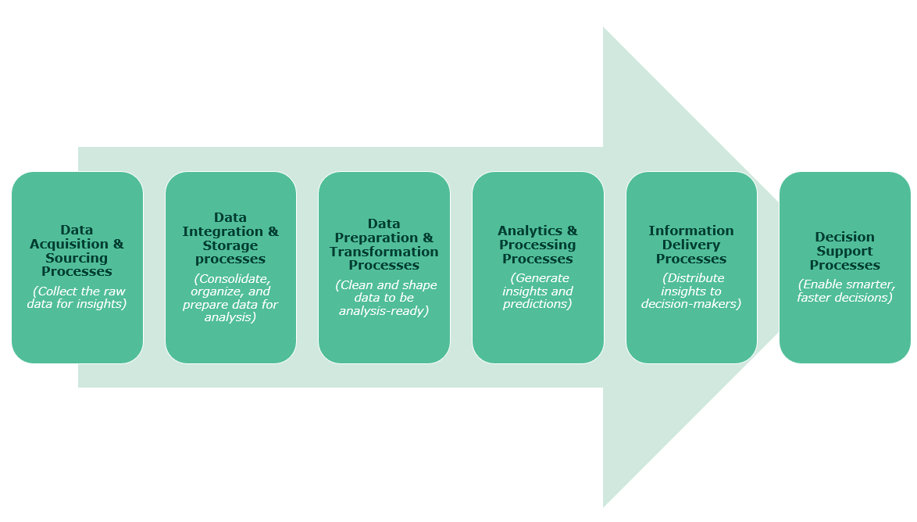
Figure 1: BIAR Business process
The list of processes below is intended to be a sample and not an exhaustive list of all processes.

Data Acquisition & Sourcing Processes
The following processes are involved in collecting the raw data:
- Ingest internal data sources
- Integrate external data sources
- Ingest unstructured metadata

Data Integration & Storage processes
The following processes consolidate, organize and prepare data for analysis and reporting:
- Extract, Transform, Load (ETL) processes
- Catalog data and manage metadata
- Preserve historical data (archiving)
- Set up data security, privacy, and compliance controls

Data Preparation & Transformation Processes
The following processes clean and shape data to be analysis-ready:
- Create views and curated datasets
- Enable feature engineering for ML

Analytics & Processing Processes
The following processes generate insights and predictions:
- Explore data using JupyterLab/ Notebooks
- Run descriptive, diagnostic, predictive analytics
- Build, train, and validate machine learning models
- Store and expose model outputs
- Create dashboards/ reports
- Create interactive reports and self-service analytics

Information Delivery Processes
The following processes distribute insights to decision makers:
- Publish dashboards
- Generate reports
- Schedule reports
- Expose datasets and model outputs
- Share interactive notebooks for advanced users

Decision Support Processes
The following processes enable smarter, faster decisions:
- Integration with business workflows to support case and investigations management processes
- Inform rules tuning and anomaly detection
- Provide evidence/ reporting for regulatory or legal escalation
- Provide data to the simulation sandbox

Data Product Classes
Data product is a term used to describe various types of information delivery outputs from the BIAR ecosystem and represent the end products delivered to users (directly or indirectly) to drive insight, decision-making, investigation, or regulatory action. The main categories or classes of data products are:
- Reports - Static or parameterized documents that summarize data in tabular, textual, or graphical form, typically designed for print or download, and used for regulatory, compliance, or operational reporting
- Dashboards - Interactive, real-time visual summaries composed of multiple charts, KPIs, and filters that allow users to monitor metrics, trends, and performance indicators at a glance
- Visualizations - Individual or embedded graphical representations such as bar charts, heatmaps, timelines, or network graphs that reveal patterns, relationships, and anomalies in for exploration or communication
- Notebooks - Interactive documents (e.g. Jupyter Notebooks) that integrate code, narrative text, queries, and visualizations in a single interface to support data exploration, experimentation, and reproducibility
- Data sets - Curated, reusable datasets or queryable data views that serve as authoritative sources for analysis, dashboards, machine learning, or sandbox experimentation
- Analytics – A broad category that includes statistical models, forecasts, scoring algorithms, ML models or anomaly detection techniques derived from structured or semi-structured data to drive decision-making and insight generation
- Model outputs - Data fields or artifacts generated by trained machine learning models (e.g. fraud scores, risk classifications) which are consumed by dashboards, reports, or integrated into case and investigation management

Information Delivery Tools
The following tools should be integrated into the BIAR ecosystem to deliver the data products required
- Jupyter Notebook is the original web-based interactive computing environment. It provides a simple interface where you can create documents that combine live code, equations, visualizations, and narrative text.
- JupyterLab is the next-generation interface that's designed to eventually replace the classic Notebook. It provides a more flexible and powerful environment with a modular design to be able to work with multiple notebooks, text files, terminals, and data visualizations all within the same browser window. As an IDE (Integrated Development Environment) built around the notebook paradigm, it enables interactive data exploration, data preparation, feature engineering, and model training for Data Science and Machine Learning, and real-time analytics.
- JupyterHub is a multi-user server that allows you to deploy Jupyter environments (either Notebooks or JupyterLab) for multiple users. Instead of each person running Jupyter on their own machine, JupyterHub provides a centralized way to serve Jupyter environments to multiple users. It handles user authentication, spawns individual Jupyter servers for each user, and manages computational resources.
- Solara is an open-source Python framework that lets you build interactive, production-ready web applications and dashboards directly from Jupyter notebooks or Python scripts, using the Jupyter kernel and familiar tools like pandas and Plotly.
- Voila is an open-source tool that converts Jupyter notebooks into interactive, standalone web dashboards by hiding the code and displaying only the outputs (e.g. charts, widgets, tables), making it ideal for sharing data-driven applications with non-technical users.
- Superset is a fully open-source self-service Business Intelligence tool that enables users, including investigators, analysts, and supervisors—to create dashboards, explore data, and build reports without writing code. It supports drag-and-drop charting, SQL-based queries, and interactive filters across multiple data sources. Superset integrates with Keycloak for authentication and supports role-based access control, making it a secure and scalable choice for democratizing data access across the BIAR ecosystem.

The following table summarizes the distinguishing features of the various information delivery tools outlined above i.e. what types of data products will be produced by which tools.
# | Output Type | Purpose | Tool/Technology | Audience | Distinguishing Features
1 | Solara Web Apps (Python-based dashboards) | Fully interactive, app-like BI interfaces using Jupyter data and logic | Solara | Investigators, Analysts | - Python-native components  - Stateful UI (filters, graphs, inputs)  - Runs from Jupyter kernel  - Drill-down tools, interactive views  - Supports large numbers of users
2 | Voila Dashboards (Notebook → Dashboard) | Clean, non-technical dashboards created from Jupyter notebooks | Voila | Executives, Supervisors, Non-technical users | - No code exposed  - Widgets supported  - Fast delivery of reports & dashboards
3 | Notebook Reports (Narrative + Code) | Story-driven, exploratory, or regulatory reports that mix narrative, data, and visuals | JupyterLab / JupyterHub | Data Scientists, Engineers, Auditors, Compliance Officers | - Combines charts, markdown, SQL queries/a code  - Interactive querying of curated datasets  - Easily exportable to PDF/HTML
4 | Interactive Visualizations | Deep data exploration, pattern detection, anomaly analysis | Plotly, Seaborn, matplotlib, ipywidgets, Altair | Analysts, Investigators,  Data Scientists | - Highly flexible  - Supports time series, graphs, scatterplots, histograms  - Standalone or embedded  - Often included in notebooks or apps
5 | Views & Datasets | Predefined queries or tables used in dashboards, apps, and analytics | Lakehouse views, Trino access, Spark, Hudi | All technical personas | - Gold-layer curated tables  - Reuseable and trusted sources  - Creation of views and materialized datasets  - Consumed by analytics and reports
6 | Analytics | Prediction scores, clustering labels, and model diagnostics | Jupyter notebooks, NumPy, pandas, scikit-learn, TensorFlow, PyTorch, MLflow | Investigators, Data Scientists, Analysts | - Integrated into dashboards or systems  - includes models, forecasts, anomaly detection
7 | Self Service Reports | Ad hoc charts, tables, and filters created directly by users via a drag-and-drop interface | Apache Superset | Investigators, Supervisors, Analysts | - No coding required  - Filterable and schedulable  - Increases flexibility and usability for non-technical users  - Supports end user exploratory analysis

Conceptual Design
The following diagram provides the high-level architecture for the data flows between the data sources and the raw layer, the raw layer and the Data Lakehouse, the Data Lakehouse and the information delivery tools, the information delivery tools and the data products, and the data products and the data consumers.
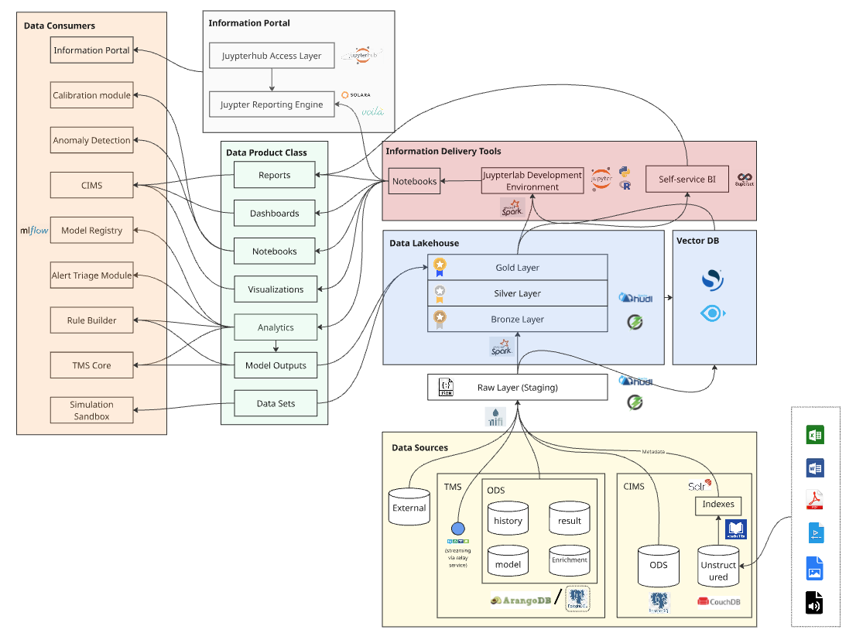
Figure 2: BIAR conceptual design

Principles and Guidance
The following table provides principles and guidance that should be applied in the design and implementation of the BIAR ecosystem. The category in the table relates to the component in the conceptual design diagram above.
# | Category | Sub-category | Principle/ Guidance | Notes
P1 | BIAR ecosystem | Deployment principle | BAIR ecosystem components must be able to be deployed in the cloud or on premises in containers (preferably Docker)
P2 | BIAR ecosystem | Licensing principle | BAIR ecosystem components should preferably be licensed under Apache 2.0 or to the left i.e. including MIT
P3 | BIAR ecosystem | Access control | RBAC in the BIAR ecosystem must be via Keycloak
P29 | BIAR ecosystem | Multi-tenancy | BIAR ecosystem components must support the Tazama multi-tenancy design as per the rest of the Tazama platform
P4 | Lakehouse | Data types | Structured (e.g. SQL, csv) and semi-structured data (e.g. JSON, xml) will be stored in the Data Lakehouse | No unstructured data (e.g. images, PDF, voice recording) will be stored in the Data Lakehouse  Data Lakehouse should be capable of serving as a centralized platform to consolidate structured and semi-structured data
P5 | Data Sources | Data source systems | The Data Lakehouse will ingest data from the following sources  • Tazama TMS ODS  • Tazama CIMS ODS  • CIMS unstructured data store  • External data sources | TMS ODS, CIMS unstructured datastore (metadata) and CIMS ODS are prioritized for now
P6 | Data Sources | TMS ODS databases | The Tazama TMS ODS (Arango DB) will supply semi-structured source data (JSON) to the Data Lakehouse from the following databases:  • Evaluation results DB  • Transaction history DB  • Pseudonyms DB  • Enrichment DB  Configuration DB | Evaluation results DB, Transaction history DB and Pseudonyms DB are prioritized for now
P7 | Data Sources | CIMS ODS data | The Tazama CIMS ODS (PostgreSQL) will provide structured and semi-structured source data to the Data Lakehouse related to:  • Case data  • Investigations data
P8 | Data Sources | CIMS unstructured data | Only metadata of unstructured data will be ingested into the Data Lakehouse. Metadata should be extracted from unstructured data using tools like Solr and Apache Tika prior to ingestion into the Data Lakehouse | No unstructured data (e.g. images, PDF, voice recording) will be stored in the Data Lakehouse
P9 | Data Sources | CIMS unstructured data store | CIMS unstructured data store will hold the following document types: Documents (e.g. Word, Excel, PDF) and Multimedia (e.g. Voice, Video, Images)
P10 | Data Sources | External data sources | Dynamic Enrichment API (DEAPI) should support the process to ingest data from external data sources into the raw layer
P11 | Lakehouse | Architectural pattern | The Data Lakehouse should follow a tiered layered architecture pattern separating data into raw storage, processing, and consumption layers | See Appendix A
P29 | Lakehouse | Technology | The Data Lakehouse should be implemented using Apache Hudi and object store (e.g. Apache Ozone)
P12 | Lakehouse | Tiered layering pattern | Raw layer - Immutable, source data as received (for traceability and reprocessing)  Bronze layer - Cleaned, schema-aligned, lightly processed data (deduplicated, validated)  Silver layer - Enriched, joined, or filtered data aligned to analytical needs  Gold layer - Curated business data models for dashboards, ML models, and reports | See Appendix A
P13 | Raw layer | Design principle | The raw layer must act as a buffer between source systems and processing, ensure traceability of unaltered source data, allow replay or reprocessing if transformation logic changes and keeps raw history for audit and governance.
P14 | Raw layer | Data format | Data should be ingested from TMS ODS in raw JSON format into the raw layer
P15 | Raw layer | Data format | Metadata should be ingested from CIMS unstructured data store and stored in JSON format in the raw layer
P16 | Raw layer | Data storage | Immutable log pattern - each raw ingestion appends to storage without deleting
P17 | Raw layer | Schema validation | Validate that data formats match the expected schema (e.g. field presence, data types) before writing into the raw layer
P18 | Data Integration | Integration pattern | Data migration integration pattern should be used, i.e. data should be moved from existing systems (e.g. operational databases) to the Data Lakehouse
P19 | Data Integration | Push-based ingestion | Ingestion layer: Data flows to Data Lakehouse should be via push-based pattern (not pull) | The process to ingest data in the raw layer must be owned and managed by the source system
P20 | Data Integration | Modular Pipeline Design | Data processing should be broken down into reusable, testable modules (e.g. NiFi flows, Spark jobs)
P21 | Data Integration | TMS ODS to raw layer | This ingestion process into the raw layer should include:  1. Event based or time-based triggers  2. Extracted JSON objects should ensure idempotency  3. Metadata for lineage, partitioning, auditing (e.g. timestamp, source ID, schema version)  4. Moving the data from Arango DB to object store (e.g. Apache Ozone) for raw staging  5. Error handling  6. Monitoring
P22 | Data Integration | Ingestion patterns | The Data Lakehouse data pipeline should support the following ingestion patterns:  1. Streaming - continuous flow of event data via relay-service (NATS) (e.g. Tazama alerts)  2. Trickle feed - small, frequent batches for near-real-time behavior (e.g. case updates/ new cases)  3. Batch - data ingested at scheduled intervals (e.g. catch up/enrichment data)
P23 | Data Integration | ETL Process | The objective of the ETL process is to take raw ingested data, clean it, enrich it and persist in Lakehouse for consumption.  This ETL process should include:  1. Raw data has been parsed, validated, and structured  2. Transformation / normalization of data (e.g. flatten nested structures, rename fields, apply business rules, derive new fields)  3. Add Hudi metadata (e.g. set record keys (transactionID, _key), partition keys (event_date), pre-combine fields (updated_at))  4. Write to the Data Lakehouse tables  5. Auditing and logging (e.g. log record count, write status, rejected rows)
P24 | Lakehouse | Schema validation | Ensure transformed data conforms to target schemas used in analytics or reports and prevent schema drift
P25 | Vector DB | Design principle | Integrating a vector database (e.g. OpenSearch or ) should enable a new class of analytics over structured data by leveraging vector embeddings enabling similarity search across entity profiles (e.g. fraudulent behavior patterns) and embedding-powered clustering, classification, and anomaly detection
P26 | Data Products | Information delivery pattern | Data products should be made available on-demand or scheduled and delivered
P27 | Data Products | Datasets | Expose datasets and model outputs via extract or export
P28 | Information delivery | Jupyter Labs | Integrating JupyterLab with the Data Lakehouse must provide an interactive environment for data exploration, analysis, and development
P29 | Lakehouse | Data | Data stored in the Lakehouse will be secured and encrypted | Masking of data will be controlled by the database layer
P30 | Simulation Sandbox | Data | Historical data will be pushed from the Data Lakehouse (BIAR) to the simulation sandbox (and not pulled) | Simulation sandbox will not be integrated into the Data Lakehouse  Data will be masked when extracted from the Data Lakehouse for Simulation Sandbox purposes  Historical data pushed from the Data Lakehouse will mimic the Tazama ODS database structure  Historical data pushed from the Data Lakehouse to the Simulation Sandbox will be tenant aware
P31 | Simulation Sandbox | Synthetic data | Synthetic data will not be stored in the Data Lakehouse or sourced from the Data Lakehouse | Synthetic data required in the Simulation Sandbox will be generated within the BIAR ecosystem by a JupyterLab notebook
p32

Appendix A: Layered Architectural Pattern
The following table provides a summary of the features that differentiate the raw layer from the various layers (Bronze, Silver, Gold) in the Data Lakehouse
Layer | Purpose | Data Quality | Transformations | Use Cases | Write Type | Format | Tools
Raw | Immutable backup of unprocessed source data | Unvalidated, as-is from source | None (minimally processed) | Data recovery, audit trail, debugging, replay, historical backup | Append-only | JSON, CSV, Parquet (unoptimized) | Apache NiFi, NATS, API ingestion
Bronze | Store ingested data in a standardized format with minimal transformation | Basic validation (e.g. format checks) | Light (format standardization, minor parsing) | Preprocessing for further ETL, operational staging | Upserts or append depending on use | Parquet, Avro (standardized) | Apache Hudi (bulk insert), Spark ingestion jobs
Silver | Validated, enriched, and cleansed data ready for analytics | High; includes deduplication, enrichment, type casting | Moderate (joins, enrichment, filtering) | Exploratory analysis, training models, dashboards, JupyterLab queries | Incremental processing or scheduled batch | Optimized Parquet with Hudi indexing | Apache Hudi (upsert), Spark SQL, dbt (data build tool)
Gold | Highly curated, business-ready datasets for reporting and ML | Very high; fully governed, normalized, and reliable+ | Heavy (aggregations, pivots, dimensional modelling) | Regulatory reporting, business KPIs, ML features, Superset dashboards or curated views for investigators | Materialized views or scheduled transformations | Optimized columnar Parquet with metadata tracking | Hudi Incremental Queries, Superset, Jupyter, dbt (data build tool)

